## The ONE Thing by Gary Keller [ SUMMARY HINDI SCRIPT]

### Hello Friends,

Kya aap,… apne apko kabhi puchha hai? Aisa may kya karu jisse karne ke bad mera life assan ho jayee ya phir aur kuch karne ki jarurat hi na pade. Duniya me app jitne bhi millionaires ya phir billionaires ko dekhenge vo sirf ak cheeze ke liya life me successful bane hai. Aur vo ak cheez unki life ko batter, easier and wealthier banaaya hai.

For example :

**Larry Page** ke life me vo ak cheez hai **Google**,

**Mark Zuckerberg** ke life me vo ak cheez hai **Facebook**.

**Jeff Bezos** ke life me vo ak cheez hai **Amazon**.

**Sachin Tendulkar** ke life me vo ak cheez hai **Cricket**.

**Bill Gates** ke life me vo ak cheez hai **MicroSoft.**

**Kisi ne sahi kaha hai :**

**Successful people don't do different things, they do same things differently.**

Aap jitne bhi millionaires aur billionaire ko dekhenge vo unke life me sirf ak cheez ke vojaise most successful bane hai. Aap bhi unke jaise successful ban sakte hai, aap jo bhi field me ho, jaise bhi kam kar rahe hoo. Aap ko sirf ak cheez jo apko successful bana sakta hai usko identify karna ho gaa aur usko puri concentration, dedication, planning aur focus ke sath implement kar na hoga, kuch expert strategy aur plans follow kar na hoga.

Jyada tar log mante hai hai ki success ke liya dedication most important factor hai. Ye ak myth hai ki complete discipline ke sath hi, Hum successful ban sakte hai. Aap discipline ko kaam use kake life me successful ban sakte hai kyonki author kehate hai.

“ **Success is about doing the right thing, not about doing everything right.** ”

Top of Form

Bottom of Form

Chaliya jante hai Yee video kin logoke liya bahut jaruri hai..?

• Ye video uun logoke liya hai, jin ke pass bahut jyada cheez hai karne ke liya, jo unko Koi ak cheez me focus kar ne nahi deta hai.

• Ye video unn logoke liya hai, jo bahut sare goal ko same time me achieve karna chahate hai ,, aur kuch bhi achieve nahi karpate hai.

• Ye video unn logoke liya hai jo multitasking ---- jo ak bada jhut hai uspa belief karte hai.

Agar app ye sari cheez se suffer kar raha hai aur janna chahate hai kaise inn cheezo ko solve kare. Too aap bilcul sahi jagaha pe hai. Sirf issi video ko full attention aur dedication ke sath dekhed. The five Lies between You and Your Success

**Lie 1: Everything Matters Equally**

Jub hamari life me koi most important aur urgent work aata hai. Too hum suddenly bina kuch soche, Samjhe bahut actively usse complete karne lagte hai. Pur aise karne par hum actually me hamari goal ke pass nahi pahanch pate aur usse door chale jate hai. Achiever hamesa clear hote hai apni priority per. Aur unko pate hai konsi cheez pehele karna hai aur kun si badme.

Humare pass to-do list too hota hai but author kahate hai todo list ke sath sath hamare pass aak success-list hona bahut jaruri. Jo hame hamari goal pe focused rakha ne ke sath sath extraordinary result achieve karne me madut karre gaa. Agar hum dhayn se dekhangee too hamare pass bahut hi kum cheez hote hai jo hame bahut jyada matter karta hai baki doose less important cheez se. Jisse hame dhayn me rakhna chahiyee. Kisi ne sahi kaha hai…. Doing the most important thing is Always the most important thing ever.

**Lie 2: Multitasking**

Hame ya samaj na hoga ki multitasking ak bahut badi jhut hai. Ye fast moving world me jub hum do cheez ak sath karna chahate hai vo kabhi bhi achese nahi ho payagaa. Ya me nahi scientifically ye prove ho chukka hai ki agar hum multitasking karte hai to hum ak bhi kam ko sahi tarike se nahi kar payangee. Researcher bolte hai ki multitasking karne se hum hamari work efficiency se 28% less efficient hojate hai. Jo hame hamari goal me focused nahi rakhpata hai aur focus ko divide kar deta hai . Foucs bahut jaruri hai koi bhi goal aur dream ko achieve kar ne ke liya.

For example agar hum ak paper ko heavy sunlight ke pass rakhte hai to vo sirf garam hoga purr jalega nahi. But agar hum ussi sunlight ko ek power glass ke madut se focused karde to vo paper.. pal-bhar me jal jayegaa. So multitasking karna bund kare aur apni puri focus sirf ek cheez only one thing me lagayee aur usse complete kare.

**Lie 3: A Disciplined Life**

Aksar hame sun ne ko milta hai ki agar app discipline rahoge to ap ko success milega. Actually me ye true hai but reality me app thodi kum decipline me bhi success ko achieve kar sakte hai. Author kehate hai… **success is about doing the right thing, not about doing everything right**.

Success pane ke liya trick hai ki. Ak right habit ko kare aur thodi si discipline ko follow kare jub tak vo task complete nahi ho jata. Ak average habit banana ke liya only 66 days lagta hai . Obviously ye habit banana easy nahi hoga but itna muskil bhi nahi hai, so agar koi muskil aye to uska samna kare aur jaldi give up na kare.

**Lie 4: Willpower Is Always on Call**

Hum soch te hai ki mere pass unlimited willpower hai. Jo ki ak jhut ke siva aur kuch nahi. Willpower ak battery ki tarah hai. Hum jitna usse use karenge vo utna khatam hota jayagaa. Din ke suruwat me hamari willpower bahut strong hota hai. Aur ye dhire dhire khatam ho ke evening tak very low hojata hai. So author kahate hai hame hamari most important vo ONE Thing .. early morning khatam karna bahut jaruri hai. Hamari will power khatam hone se pahe le.

**Lie 5: A Balanced Life**

Author kahate hai ak balanced life ak bahut badi jhut hai. Hum ak din 24 ghante me sari cheezo ko cover nahi karsakte. Hamesa kuch na kuch pichhe choot jata hai. Hum Jitna bhi kosis kar le hamesa kuch na kuch baki rahajata hai. Jo hamare liya sabse jaruri hai usse complete kare aur ye samjhe ki at a time hum subkuch complete nahi kar sakte aur usse accept kare. Ye hamesa yaad rekhe ki …hum jub koi important priority ke upper kam karte hai to hum automatically out of balance ho jate hai, isss reality ko accept kare.

Abhitak hum jane ki hamari success me kya kya rukabat aata hai.

Ab hum janenge.. kaise usska samna kare.

**THE PATH TO PRODUCTIVITY**

Aap ke vo ONE Most Important Thing janne ke liya yee Focusing Question apne aap se puch na bahut jaruri hai :

**“What’s the ONE Thing I can do such that by doing it everything else will be easier or unnecessary?”**

Agar aap ke pass ek long-term goal hai, Author kahate hai ak bar aap apni goal set karne ke bad, apko usse break karke chote chote actionable steps banana hoga.

**How to set purpose and priorities**

for example:

Goal setting for **some day** .

Mera long term goal hai, ki may ye Life Learner youtube channel pe 10 million subscriber tak pahachu.

Next hoga panch – sal ka goal

Mere SomeDay goal ke adhar per, me kaya kay karu in panch sall me.?

Jaise ki – panch sall me mujhe kaise bhi karke 1 million subscribers ke pass pahanch na hai.

Next Hoga ek sal ka goal

Mere panch sal goal ke base pe mera next ak sal ka goal hoga ki me kaise bhi karke 100K subscriber ke pass pahanchu.

Next hoga ek mahina ka goal

Mera ak mahina ka goal hoga ki har mahina mere channel pe 7-8K Subscriber hona chahiya.

Next hoga ek week ka goal

Mera ak week me mujhe sirf 2k subscriber tak pahanch na hai.

Last me hoga mera daily goal

Mera daily goal ye hoga ki me sirf 50-60 subscribers ke pass pahanchu. Weekly video upload karke aur achhi content bana ke ye final goal me jarur hasil kar sakungee.

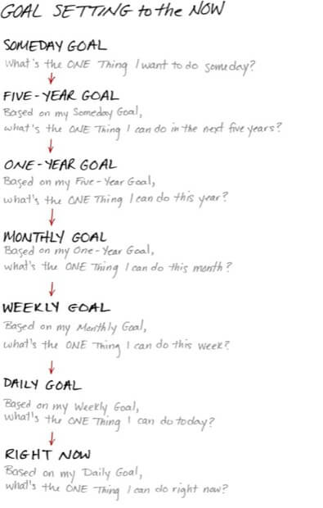

Planning karne ke bad next aat hai Productivity. Abhi tak aap ko samajh me agaya hoga ki

**only planning no action is nothing but Failure**.

Author kahate hai ki **productivity is the driving force behind your successes**.

To hame agar productive ban na hai to hame hamari daily calender ka time block kr ke vo The ONE Thing ko dedicated ly kar Bahut jaruri hai. Aap rose kuch specific time jaise ki 4-6 hours de kar apki vo ONE Thing ko productivie bana sakte hai.

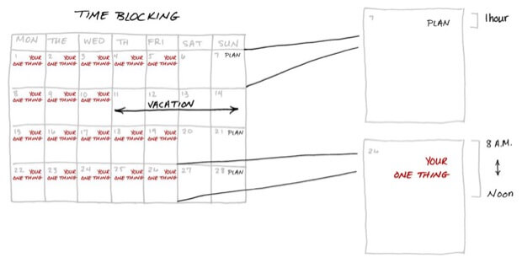

To conclude author Keller kahate hai hame 3 key commitments karna hoaga time aur goals ko setup karne ke liay.

1. Adopt the mastery mindset.

Apni mindset ke upper mastry hasil karo. Koi kuch bhi kahe apne apko tutne mut do aur total focus aur dedication se apni one thing pe lagjaooo.

1. Continually be learning the better way to do something.

Aap ek cheez kuch samay ke liye kar rahe hai aur wo kam kar raha hai ..iska matlab yeh nahi ki wo sirf best tarika hai. Hamesha ek learning attitude ko maintain kare aur apne apko improve kare. Perfection tabhi ata hai jab hum apni khubiyon me bhi khamiyan talashe…

1. Hold yourself accountable.

Aap jimedar hai apke wo ONE THING ke liye aur kebal aap hee sunishchit karsakte hai ki aap is us tak pahunchane ke lie har sambhav koshish karenge.

Me ye knowledge share kar rahi hoon ak fascinating or wonderful book “The ONE Thing by Gary Keller”. Agar aap ye book ko kharid na chahate hai to description me apko link miljayaga. Agar apko free eBook chahiyee to niche comment kijiye.